Full ADHD Causal Network
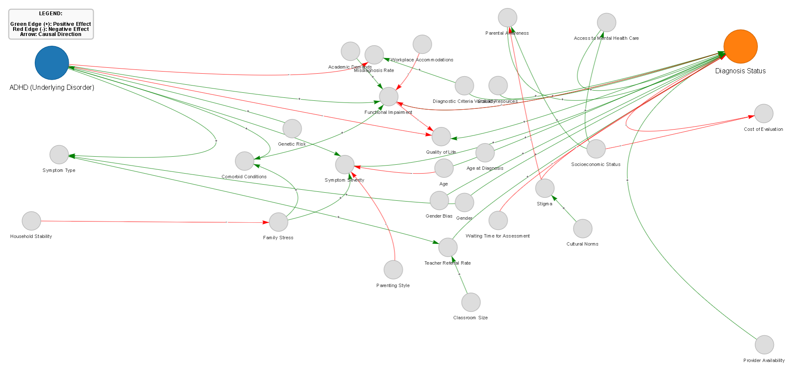
Interpretation: The original causal network represents the relationships between ADHD, mediating behavioral factors, and contextual variables influencing diagnosis outcomes. ADHD acts as the root cause affecting symptom severity, functional impairment, and quality of life, which subsequently influence diagnostic status. External influences such as socioeconomic status, stigma, access to care, and family stress interact with these mediators. However, the visualization is dense and overlapping, making it difficult to clearly interpret causal pathways or relative influence of factors.
Full ADHD Causal Network with edits
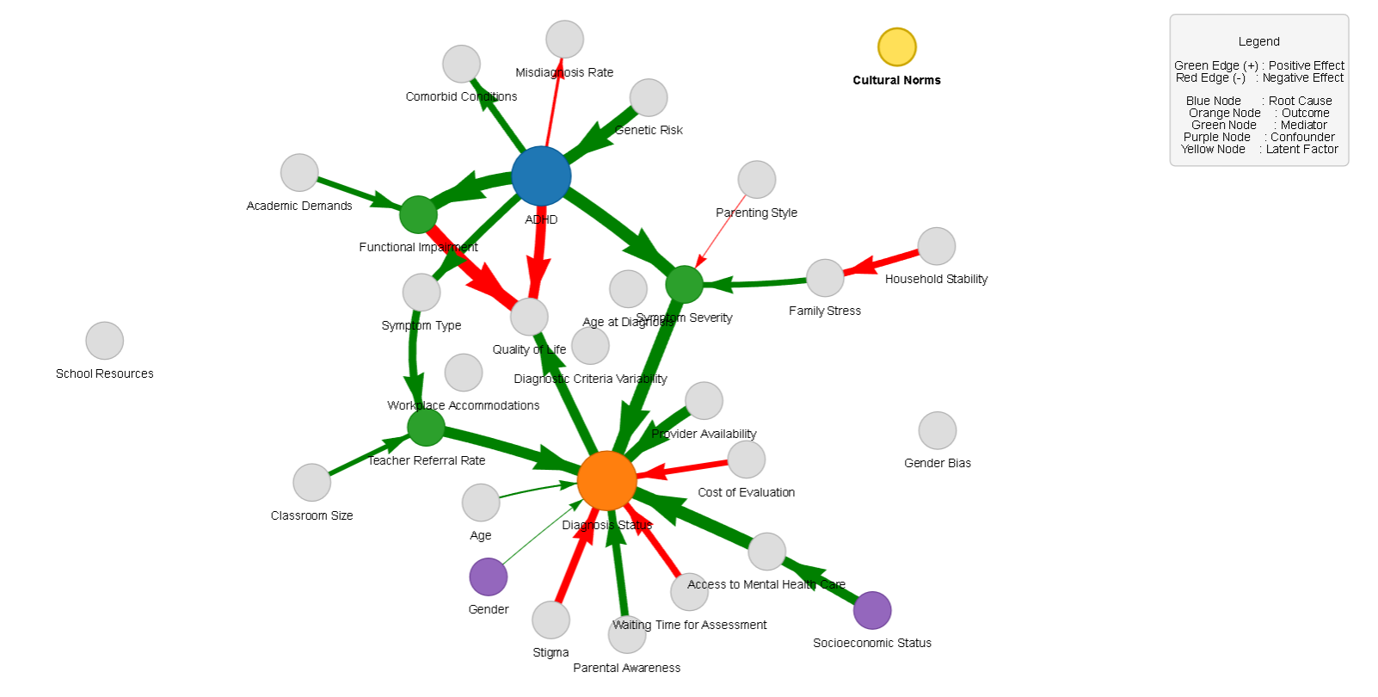
Interpretation: The edited causal network improves interpretability by organizing nodes using a physics-based layout and categorizing variables into root causes, mediators, confounders, and latent variables. Edge widths represent causal power, allowing stronger causal influences to be visually distinguished. ADHD remains the primary causal driver influencing mediators such as symptom severity and functional impairment.
Persona – 1
45-year-old male, hyperactive ADHD, low SES, high stigma, undiagnosed

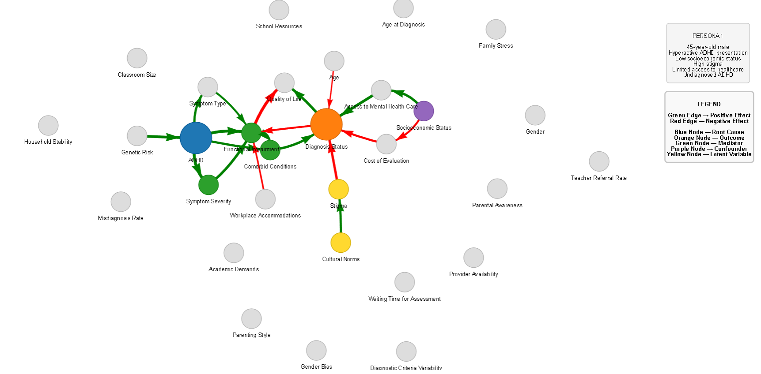
Interpretation: The edited persona graph highlights the key causal pathway more clearly: ADHD → symptom severity → functional impairment → diagnosis status. Socioeconomic barriers, stigma, and evaluation costs act as confounders that weaken the pathway toward diagnosis. The improved visualization emphasizes how structural barriers outweigh symptom visibility in determining diagnostic outcomes. This persona illustrates delayed or absent diagnosis despite clear clinical indicators.
Persona – 2
8-year-old child with combined ADHD presentation
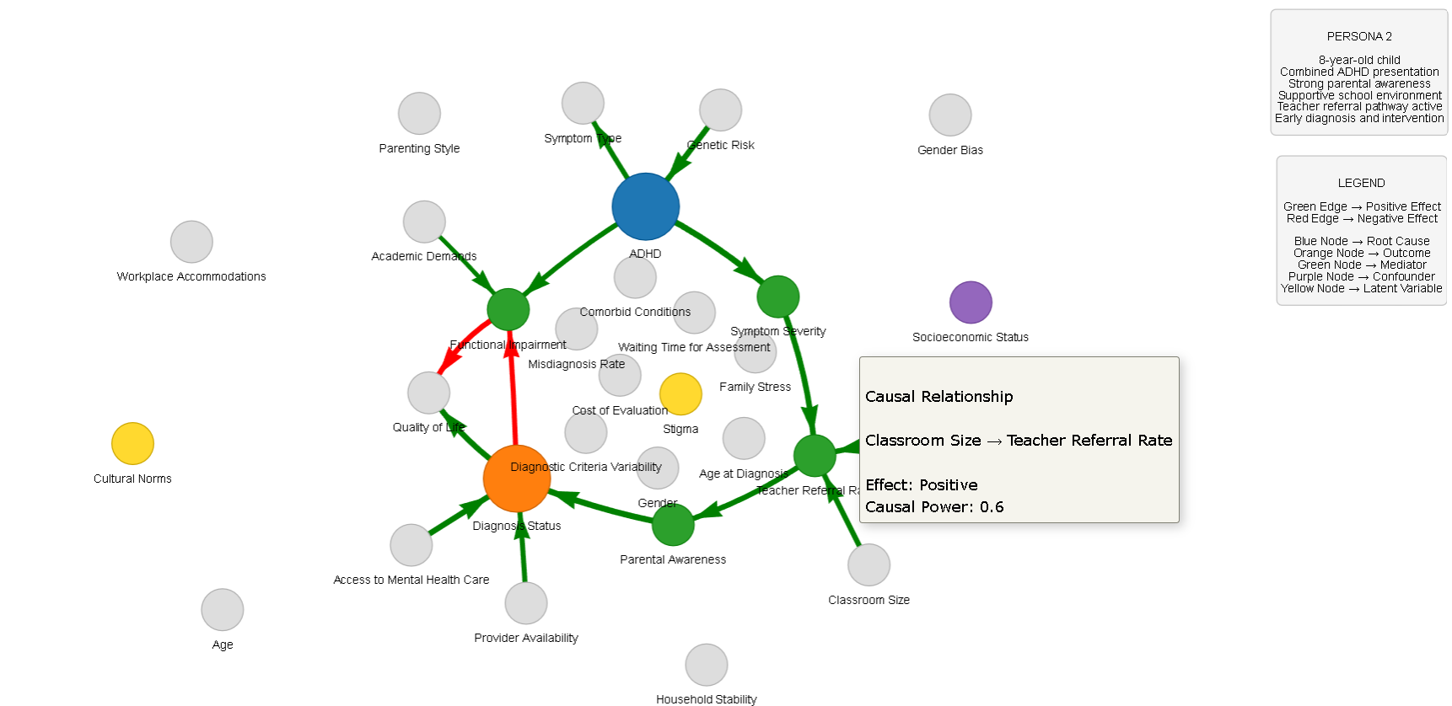
Interpretation: In this persona, ADHD symptoms manifest early and are quickly recognized due to supportive environmental conditions. Parental awareness, school resources, and active teacher referrals strengthen the pathway leading to early diagnosis. Mediators such as functional impairment and symptom severity trigger intervention mechanisms within educational and healthcare systems. This network demonstrates how supportive institutional structures accelerate the diagnostic process.
Persona – 3
30-year-old adult with inattentive ADHD, high SES
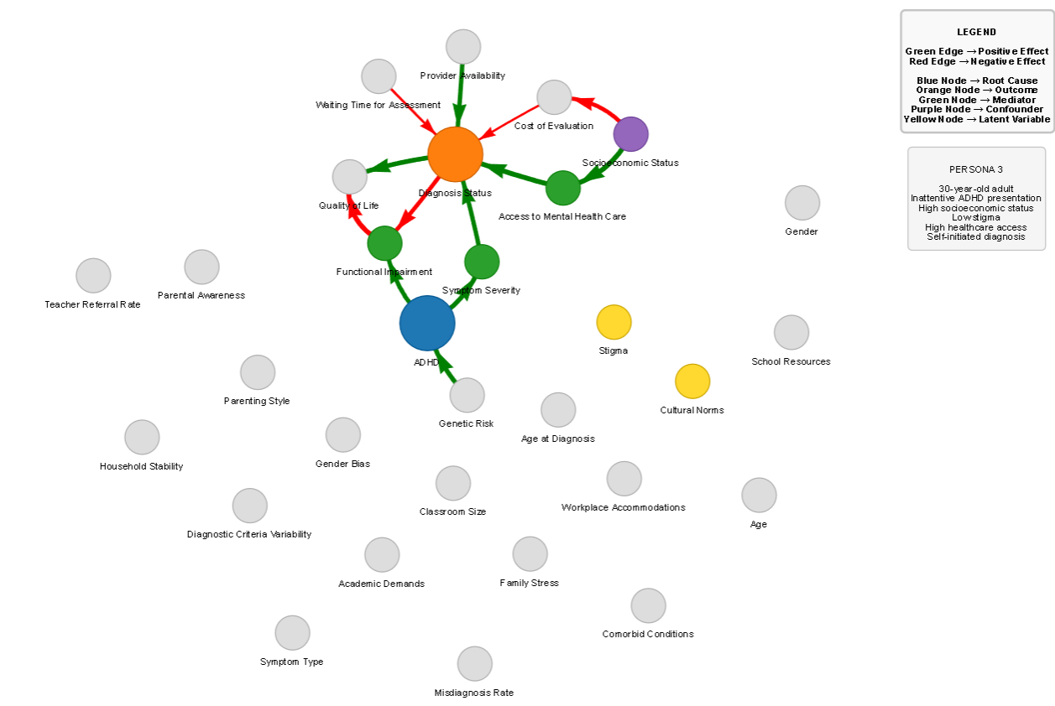
Interpretation: This persona represents an adult who self-identifies symptoms and actively seeks diagnosis. High socioeconomic status and strong healthcare access reduce systemic barriers, enabling direct pathways to evaluation and diagnosis. Mediators such as functional impairment and reduced quality of life motivate help-seeking behavior. The network highlights how resource availability and reduced stigma facilitate earlier recognition in adulthood.

Persona – 4
28-year-old adult with high comorbidity burden
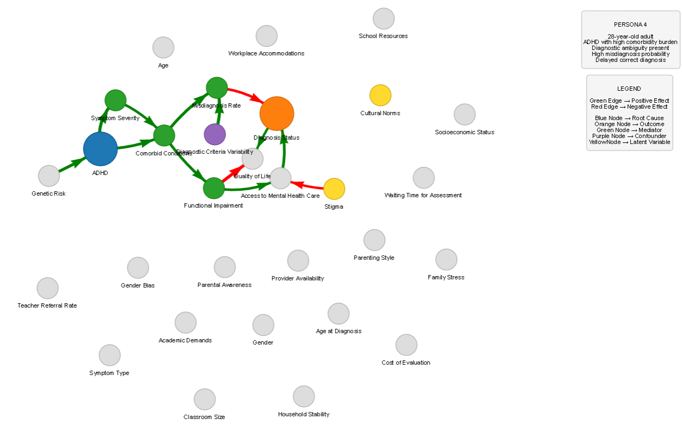
Interpretation: In this scenario, ADHD symptoms interact with comorbid conditions, increasing diagnostic complexity. Comorbid disorders and variability in diagnostic criteria introduce ambiguity in clinical assessment, leading to misdiagnosis or delayed recognition. Mediators such as functional impairment and healthcare access still influence outcomes, but diagnostic accuracy is affected by overlapping symptom profiles. This graph illustrates how clinical complexity can obscure the causal path to correct diagnosis.

Persona – 5
35-year-old adult with persistent ADHD and major systemic barriers
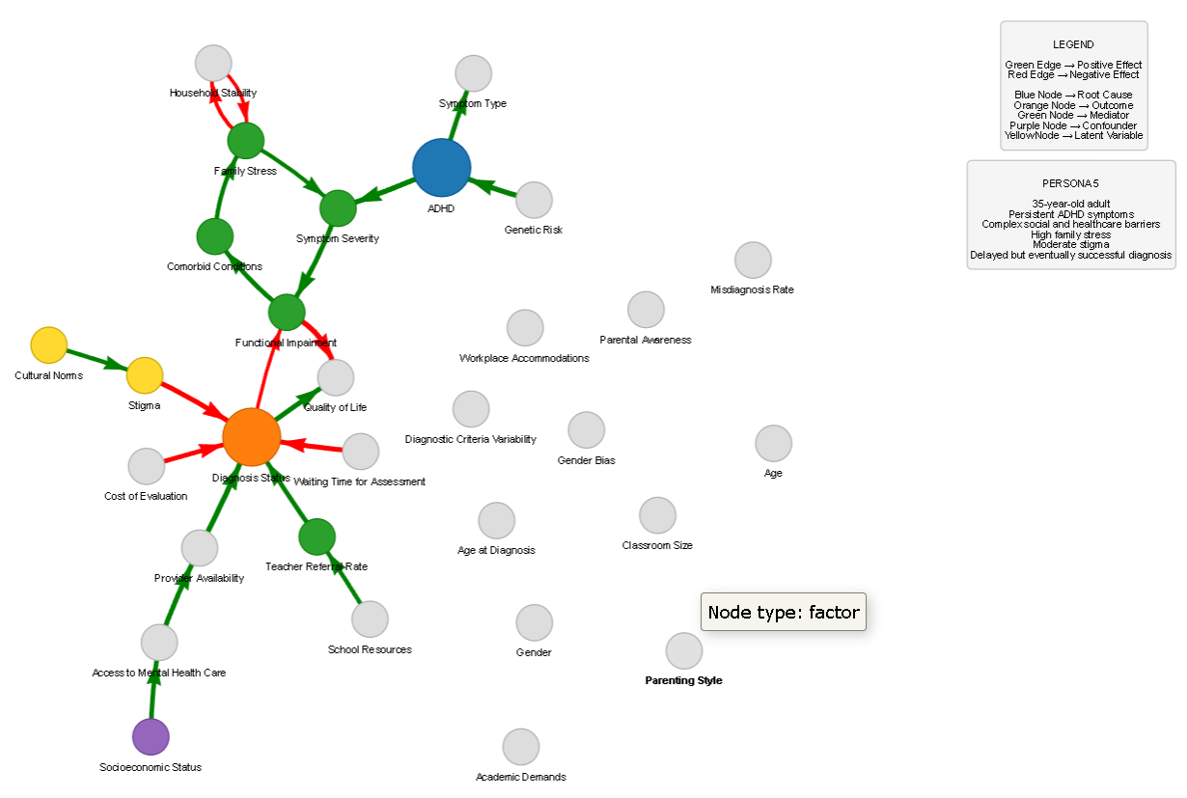
Interpretation: This persona highlights how socioeconomic disadvantage, stigma, and high stress levels delay diagnosis despite persistent ADHD symptoms. ADHD increases symptom severity and functional impairment, which negatively affect quality of life. Cultural stigma and healthcare barriers further obstruct access to diagnostic evaluation. Eventually, intervention occurs through institutional pathways such as teacher referral or healthcare access, leading to a delayed but successful diagnosis.

